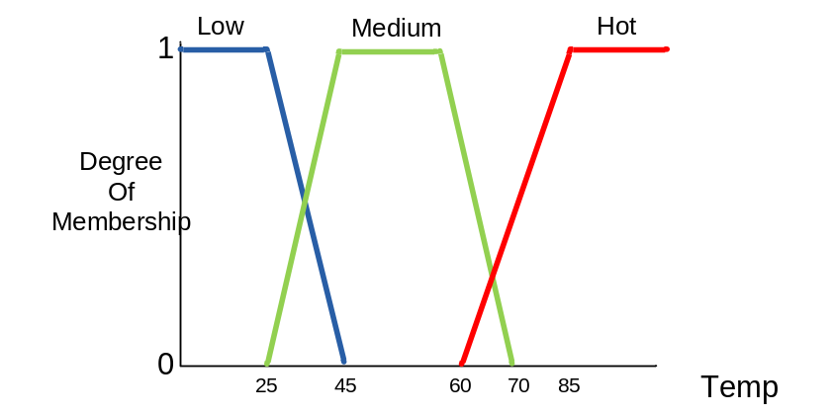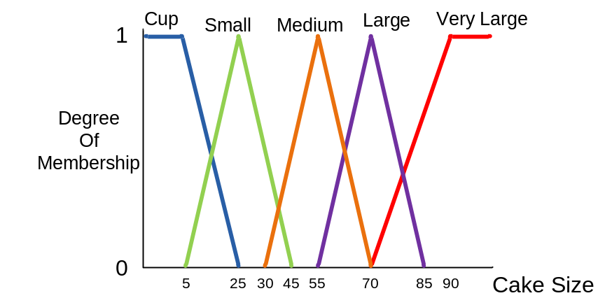

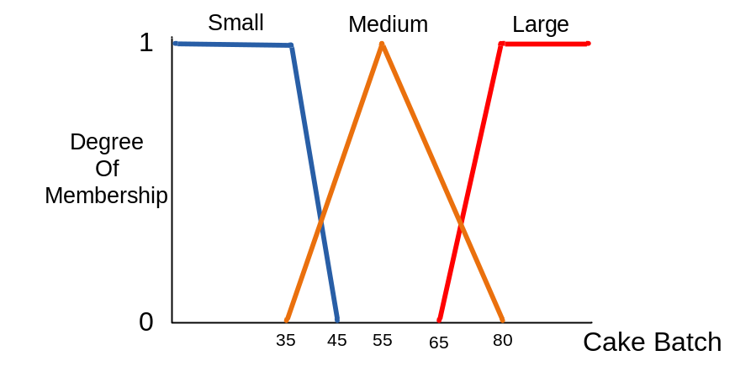
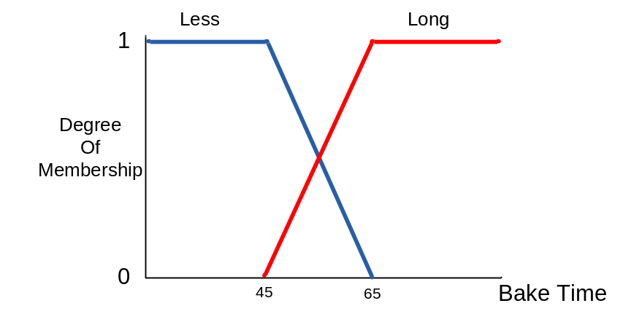

Figure 1: Membership function

IF Cup Cake Size AND Low Temp AND Large Batch THEN Long Time
IF Cup Cake Size AND Hot Temp AND Large Batch THEN Less Time
IF Large Cake Size AND Low Temp AND Large Batch THEN Long Time
IF Small Cake Size AND Low Temp AND Small Batch THEN Less Time
Figure 2: Control rules

Figure 1 shows the membership function of fuzzy image processing systems and Figure 2 shows the system control rules. Using jFuzzyLogic tool and program the problems.
- Find the time to bake the cake with 20 cm cake size, 40 degree temp, and 75 cakes batch.

Print out the coding and the print screen the solutions and submit it before 7th December 2016 (Wednesday) before 4.00pm.

